Student Supply List

Second Grade

South Knoxville Elementary

Classroom Teachers: Mr. Johnson and Mrs. Ramsey

Pencils

Cap erasers

Zipper Pencil Pouch

Plastic Pencil Box

Box of Crayons

Pair of Scissors

Package of Post It Notes

2- 1 subject spiral bond notebooks

Package of Copy/Printer Paper

Pair of Headphones

Primary Composition Book

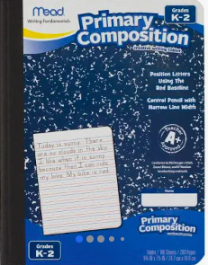

For the Classroom

Clorox Wipes

Kleenex

Box of Gallon Size Ziploc Bags